**TEST PLAN**

**Website Name : DEMO BLAZE**

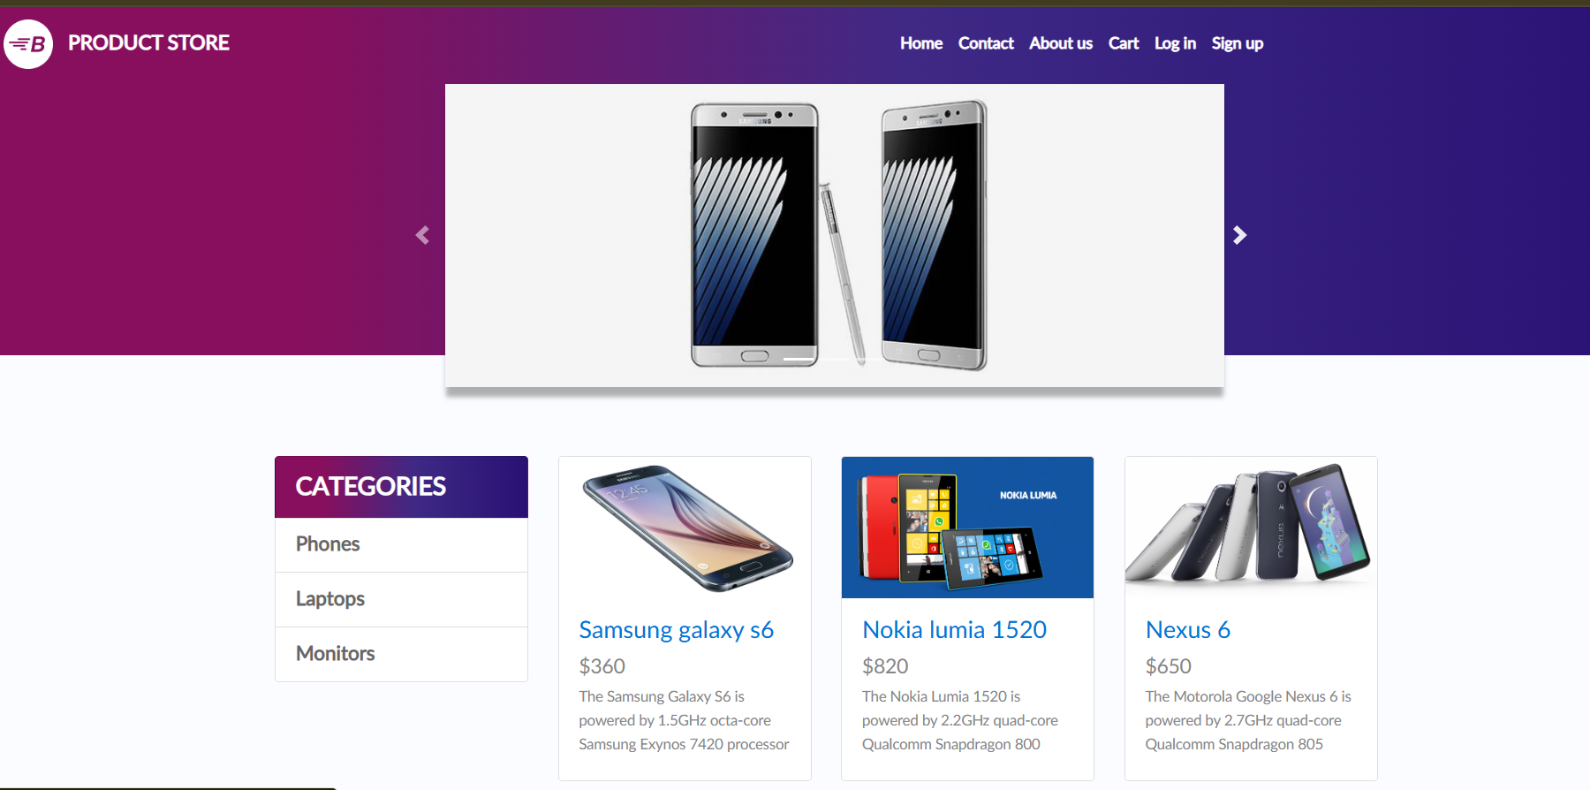

***Prepared by : PujaKumari***

***Date : Feb 28,2025***

**Points to Visit :**

1) Introduction

2) Objective

3) Scope

4) Feature To be Tested

5) Testing Approach

6) Roles and Requires

7) Test Schedules

8) Test Deliverables

9) Entry and Exit Criteria

10) Tools Required

11) Risks and Mitigation Plans

12) Approvals

**✔ Introduction :**

**⮚** *This Document has been created to represent the working functionality of the site DEMO BLAZE using the few test cases and other procedures.*

**✔ Objectives :**

**⮚** *To check the functionality of the application checkout functionality.*

***⮚*** *Doing the usability Testing.*

✔ **SCOPE :**

**⮚** *To check the working functionality of the DEMO BLAZE Web Application.*

***✔* Feature To be Tested :**

***⮚*** *Checkout Functionality of the Web Application.*

***✔* Testing Approach :**

***⮚******Testing Methods -***

*I ) Functional Testing*

*II) Usability Testing*

*III) Performance Testing*

***⮚******Testing Environment :***

*I) UAT*

*II) Pre-Prod*

***⮚ Testing Supportives :***

*I) Windows should be 11 and Above*

*II) Tools : Cypress, Jira*

*III) Browsers Supported – Chrome , Firefox, MS Edge*

$✔$**Roles and Requires :**

Test Manager : Shiva Kumar

**⮚** *Role => Manages the Projects , Resolves the conflicts between the*

*members regarding projects , Solve the issues regarding project,*

*Validates the movement of the ongoing projects .*

Test Engineer : Puja Kumari

***⮚*** *Role => Understand the Customer Requirements, Divides the*

*responsibility between the team members , Resolve the small issues*

*in the project, Creates the Test Plans and Strategies for the*

*development of Project , Supports in Creation of the test cases of*

*Functional and Usability Test Cases, Finalises the Bug Reports ,*

*Gives the suggestion of Practical works in the Team .*

Test Engineer : Nashrah Khanam

***⮚*** *Role =>Understand the Customer Requirements, Finalises the*

*Automation testing API with Postman and RestAssured, Performing the Root cause of a particular defect and does the analysis.*

Team Lead : Palak Mangal

***⮚*** *Role =>Understand the Customer Requirements, Finalises the*

*Automation testing Cucumber Framework with POM via Selenium, Performing the Root cause of a particular defect and does the analysis.*

**Test Schedule :**

*Test Plan Creations : 28/02/2025*

*Test Scenarios : 01/03/2025*

*Test Cases Creation : 01/03/2025 – 02/03/2025*

*Test Cases Execution : 02/03/2025*

*Summary Report Submit : 02/03/2025*

**Test Deliverables (For the Client) :**

*Test Plan - All the works and plans has been created regarding the scope*

*of the DEMO BLAZE Web Application.*

*Test Cases - Test Cases has been created for the functionality given using*

*the functional and usability test cases*

*Defects - Defect Reports has been created separated which are present in*

*the functionality given*

*Test Summary Report -Final report summarizing test coverage, outcomes,*

*and any unresolved issues.*

**ENTRY AND EXIT CRITERIA**

**Requirement Processes’**

**Entry Criteria:**

*In this process, the testing team receives the Requirements documents and*

*use documents of the project from the Business Analyst.*

**Exit Criteria:**

*The testing team has completed the whole understanding of the project and*

*were ready to proceed for the Test Planning.*

**====**

**# Test Planning**

**Entry Criteria:**

*This document shows the Test Strategy needed for the planning of the*

*project. The planning has started by reviewing the features by the testers.*

**Exit Criteria:**

*The Plan is now ready and the Team is just waiting for the approval of the Client i.e. of DEMO BLAZE.*

**====**

**# Test Designing**

**Entry Criteria:**

*We have the documents signed by the client and now the team is ready for the*

*proceeding to the designing of the Project.*

**Exit Criteria:**

*To Exit the criteria we have already created the Test Scenario and the Test Cases and are ready to move on.*

**==================**

**#Test Execution**

**Entry Criteria:**

*Since the Test Case and Test Scenarios are ready they are ready to get signed off*

*the Client. Then only the team will start working on projects manually.*

**Exit Criteria:**

*Test Cases and Defects Reports are ready to move further.*

***==========***

**# Test Closure**

**Entry Criteria:**

*Test Case Reports and Defect Reports processes have been done.*

**Exit Criteria:**

*Test Summary creation has been completed.*

**Tools Required:**

**✔** Xmind => *Tool Required for mind mapping*

***✔*** Jira *=> For managing the projects like their defect logging.*

**✔** Cypress => *Required for the automations*

**RISK AND MITIGATION/BACKUP PLANS :**

***⮚*** *Risks => i) Lack of Testers*

*ii) Don’t have enough requirements*

***⮚*** *Backups => i) Senior Testers has been available for the dependency*

*ii) Particular Associates has been called up.*

**REQUIRED APPROVALS FOR PROCEEDINGS IN PROJECT :**

*⮚ Test Plans*

*⮚ Test Scenarios*

*⮚ Reports*

*((TESTING WILL PROCEED AFTER THESE BEING SIGNED OFF BY*

*CLIENT))*

**